**Financial Loan Details Reports**

# **KPI’s :**

## Total Loan Applications :

select count(id) as Total_loan_Application from financial_loan ;



MTD Loan Applications :

select count(id) as MTD_Total_Loan_Application from financial_loan

where MONTH(issue_date)= 12 and YEAR(issue_date)=2021;

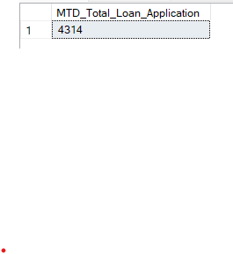

PMTD Loan Applications :

select count(id) as previous_MTD_Total_Loan_Application from financial_loan

where MONTH(issue_date)= 11 and YEAR(issue_date)=2021;



Total Funded Amount :

select sum(loan_amount) as Total_Funded_Amount from financial_loan;



MTD Total Funded Amount :

select sum(loan_amount) as MTD_Total_Funded_Amount from financial_loan

where month(issue_date) = 12 and YEAR(issue_date) = 2021;



PMTD Total Funded Amount :

select sum(loan_amount) as Previous_TD_Total_Funded_Amount from financial_loan

where month(issue_date) = 11 and YEAR(issue_date) = 2021;



Total Amount Received :

select sum(total_payment) as Total_Amount_recieved from financial_loan;



MTD Total Amount Received :

select sum(total_payment) as MTD_Total_Amount_recieved from financial_loan

where month(issue_date) = 12 and year(issue_date) = 2021;



PMTD Total Amount Received :

select sum(total_payment) as Previous_Total_Amount_recieved from financial_loan

where month(issue_date) = 11 and year(issue_date) = 2021;



Average Interest Rate :

select avg(int_rate)*100 from financial_loan;



MTD Average Interest :

select round(avg(int_rate),4)*100 as MTD_Avg_intrest_Rate from financial_loan

where month(issue_date) = 12;



PMTD Average Interest :

select round(avg(int_rate),4)*100 as Previous_Month_Avg_intrest_Rate from financial_loan

where month(issue_date) = 11;



Avg DTI :

select round(avg(dti),4)*100 as Avg_Dti from financial_loan;



MTD Avg DTI :

select round(avg(dti),4)*100 as MTD_Avg_Dti from financial_loan

where MONTH(issue_date) = 12 and year(issue_date) = 2021



PMTD Avg DTI :

select round(avg(dti),4)*100 as Previous_Month_Avg_Dti from financial_loan

where MONTH(issue_date) = 11 and year(issue_date) = 2021;



**GOOD LOAN ISSUED :**

select

(count(CASE WHEN loan_status = 'Fully Paid' or loan_status = 'Current'

THEN id END)*100)

/

count(id) as good_loan_percentage

from financial_loan;



Good Loan Applications :

select count(id) as good_loan_application from financial_loan

where loan_status = 'Fully Paid' or loan_status = 'Current';



Good Loan Funded Amount :

select sum(loan_amount) as good_loan_funded_amount from financial_loan

where loan_status = 'Fully Paid' or loan_status = 'Current';



Good Loan Amount Received :

select sum(total_payment) as good_loan_amount_recvieved from financial_loan

where loan_status = 'Fully Paid' or loan_status = 'Current';



**BAD LOAN ISSUED :**

Bad Loan Percentage :

SELECT

(COUNT(CASE WHEN loan_status = 'Charged Off' THEN id END) * 100.0) /

COUNT(id) AS Bad_Loan_Percentage

FROM financial_loan;



Bad Loan Applications :

select count(id) from financial_loan

where loan_status = 'charged off';



Bad Loan Funded Amount :

select sum(loan_amount) as bad_loan_amount_funded from financial_loan

where loan_status = 'charged off';



Bad Loan Funded Amount :

select sum(total_payment) as bad_loan_amount_recieved from financial_loan

where loan_status = 'charged off';



**LOAN STATUS :**

select

loan_status,

count(id) as total_loan_application,

sum(total_payment) as total_amount_recieved,

sum(loan_amount) as total_amount_funded,

avg(int_rate)*100 as intrest_rate,

avg(dti)*100 as dti

from financial_loan

group by loan_status;

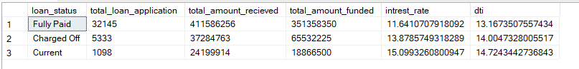

**MTD_LOAN STATUS :**

select

loan_status,

sum(total_payment) as MTD_total_amount_recieved,

sum(loan_amount) as MTD_total_amount_funded

from financial_loan

WHERE MONTH(issue_date) = 12

group by loan_status;

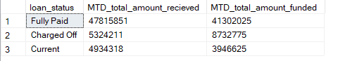

Financial LOAN REPORT | OVERVIEW :

select

MONTH(issue_date)as month_number,

DATENAME(month,issue_date) as month_name,

count(id) as total_loan_applications,

sum(loan_amount) as total_funded_amount,

sum(total_payment) as total_recieved_amount

from financial_loan

group by MONTH(issue_date), DATENAME(month,issue_date)

order by MONTH(issue_date) ;

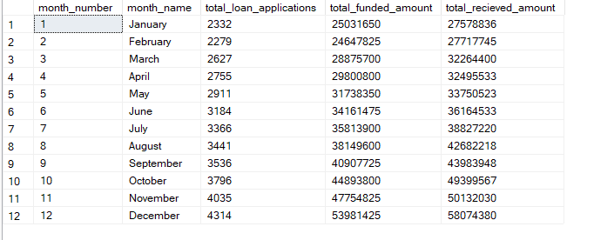

**STATE WISE :**

select

Address_state,

count(id) as total_loan_applications,

sum(loan_amount) as total_funded_amount,

sum(total_payment) as total_recieved_amount

from financial_loan

group by address_state

order by count(id) desc;

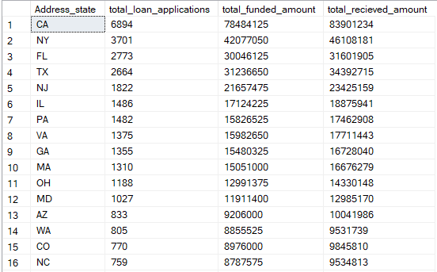

TERM WISE :

select

term,

count(id) as total_loan_applications,

sum(loan_amount) as total_funded_amount,

sum(total_payment) as total_recieved_amount

from financial_loan

group by term

order by term;

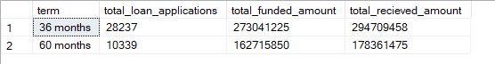

EMPLOYEE LENGTH WISE :

select

emp_length,

count(id) as total_loan_applications,

sum(loan_amount) as total_funded_amount,

sum(total_payment) as total_recieved_amount

from financial_loan

group by emp_length

order by emp_length;

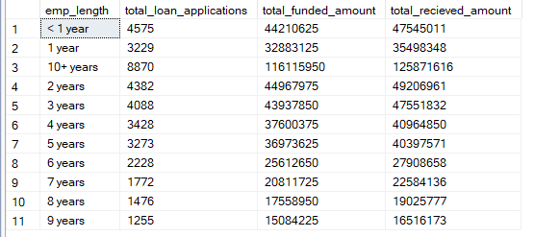

PURPOSE WISE :

select

purpose,

count(id) as total_loan_applications,

sum(loan_amount) as total_funded_amount,

sum(total_payment) as total_recieved_amount

from financial_loan

group by purpose

order by count(id) DESC;

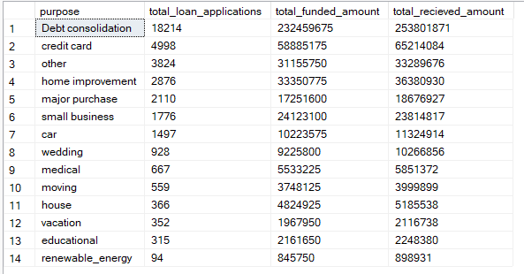

HOME OWNERSHIP WISE :

select

home_ownership,

count(id) as total_loan_applications,

sum(loan_amount) as total_funded_amount,

sum(total_payment) as total_recieved_amount

from financial_loan

group by home_ownership

order by count(id) DESC;

